PROJECT PLANNING PHASE
Project Planning Template (Product Backlog, Sprint Planning, Stories, Story points)
Date | 26 October 2026
Team ID | TEAM-EV-09
Project Name | EV Market Dynamics & Clean Mobility Intelligence Dashboard
Maximum Marks | 8 Marks

Product Backlog, Sprint Schedule, and Estimation (4 Marks)
Product backlog and sprint schedule for the EV Market Dynamics & Clean Mobility Intelligence solution.
Sprint | Functional Requirement (Epic) | User Story Number | User Story / Task | Story Points | Priority | Team Members
Sprint-1 | Data Ingestion | USN-1 | Extract multi-source EV datasets (registrations, AFDC charging repositories, OEM specs) via Python. | 5 | High | Member 1
Sprint-1 | Data Cleansing | USN-2 | Profile datasets, handle missing range/battery values, and normalize units (miles to km, kWh/100km). | 5 | High | Member 2
Sprint-1 | Data Modeling | USN-3 | Establish denormalized tables and clean schema pipelines optimized for Tableau extracts. | 5 | High | Member 3
Sprint-1 | Quality Assurance | USN-4 | Validate schema integrity, remove duplicate vehicle records, and verify data consistency. | 5 | Medium | Member 4
Sprint-2 | Trend Analytics | USN-5 | Build historical sales volume trajectory and BEV vs. PHEV market share line/area worksheets. | 5 | High | Member 1
Sprint-2 | OEM Benchmarking | USN-6 | Construct Price vs. Range scatter plots with regression trendlines and dynamic price-slider parameters. | 5 | High | Member 2
Sprint-2 | Geospatial Analysis | USN-7 | Develop geographic choropleth maps for regional adoption density and charging corridor gap analysis. | 5 | High | Member 3
Sprint-2 | Efficiency Modeling | USN-8 | Build OEM market concentration Pareto charts and vehicle class efficiency (kWh/100km) comparisons. | 5 | Medium | Member 4
Sprint-3 | Dashboard Assembly | USN-9 | Assemble interactive Tableau Dashboard with executive KPI ribbon, cross-filtering, and LOD metrics. | 5 | High | Member 1 & 2
Sprint-3 | Story Design | USN-10 | Design a 5-chapter Tableau Storyboard detailing adoption surge, charging bottlenecks, and 2030 targets. | 5 | High | Member 3
Sprint-3 | Web Integration | USN-11 | Implement Flask backend routing and embed responsive Tableau Public iframe views inside Bootstrap UI. | 5 | High | Member 4
Sprint-3 | UI Polish | USN-12 | Integrate dynamic KPI counter cards, navigation menus, and test cross-browser responsiveness. | 5 | Medium | Member 1 & 4
Sprint-4 | Performance Tuning | USN-13 | Optimize Tableau extract queries and Flask static asset delivery to achieve <3s filter latency. | 5 | High | Member 2
Sprint-4 | User Testing | USN-14 | Conduct user acceptance testing (UAT) evaluating fleet manager and everyday car buyer workflows. | 5 | High | Member 3
Sprint-4 | Deployment | USN-15 | Publish final verified workbook to Tableau Public and verify live iframe responsiveness on web portal. | 5 | High | Member 1
Sprint-4 | Documentation | USN-16 | Finalize technical solution architecture, backlog burndown tracking, and sprint sign-off reports. | 5 | Medium | Member 4

Project Tracker, Velocity & Burndown Chart (4 Marks)
Sprint | Total Story Points | Duration | Sprint Start Date | Sprint End Date (Planned) | Story Points Completed | Sprint Release Date (Actual)
Sprint-1 | 20 | 6 Days | 28 Sep 2026 | 03 Oct 2026 | 20 | 03 Oct 2026
Sprint-2 | 20 | 6 Days | 05 Oct 2026 | 10 Oct 2026 | 20 | 10 Oct 2026
Sprint-3 | 20 | 6 Days | 12 Oct 2026 | 17 Oct 2026 | 20 | 17 Oct 2026
Sprint-4 | 20 | 6 Days | 19 Oct 2026 | 24 Oct 2026 | 20 | 24 Oct 2026

Team Velocity Calculation:
Velocity represents the amount of work completed by the project development team during a single iteration (sprint). For this project, each sprint spans 6 working days, with an estimated commitment of 20 story points per sprint across 4 sprints (Total = 80 Story Points).
Average Sprint Velocity (AV) = Total Story Points Completed / Number of Sprints
AV = 80 Story Points / 4 Sprints = 20 Story Points per Sprint
Daily Team Velocity = Average Sprint Velocity / Sprint Duration (in Days)
Daily Velocity = 20 Story Points / 6 Days = 3.33 Story Points per Day

Sprint & Release Burndown Chart:
A burndown chart represents the amount of pending work versus time across sprint iterations. Below is the burndown progression tracking ideal burn against actual story points delivered through the final release on 24 October 2026 (prior to the submission milestone on 26 October 2026).
Sprint Iteration | Planned Points (Start) | Points Completed | Actual Remaining Points | Ideal Remaining Points
Sprint Start (Day 0) | 80 | 0 | 80 | 80
Sprint 1 End | 80 | 20 | 60 | 60
Sprint 2 End | 60 | 20 | 40 | 40
Sprint 3 End | 40 | 22* | 18 | 20
Sprint 4 End (Release) | 18 | 18 | 0 | 0

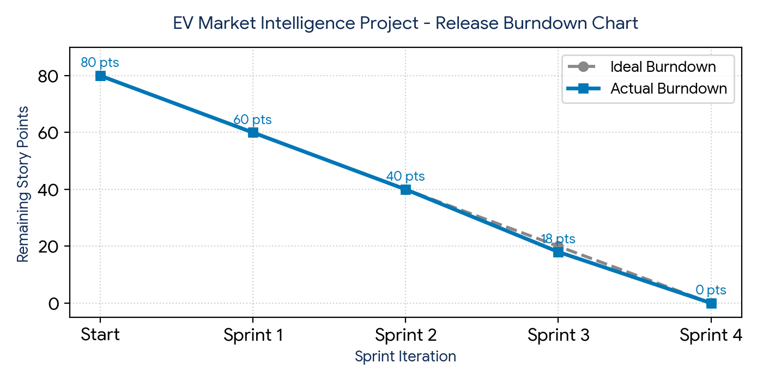
Agile References & Framework Guidelines:
• Atlassian Agile Project Management: https://www.atlassian.com/agile/project-management
• Jira Scrum & Sprints Setup: https://www.atlassian.com/agile/tutorials/how-to-do-scrum-with-jira-software
• Story Points & Estimation: https://www.atlassian.com/agile/project-management/estimation
• Burndown Chart Dynamics: https://www.atlassian.com/agile/tutorials/burndown-charts

